Between 2 consecutive notes there are 2 types of steps a half step and a whole step. A half step is one semitone and a whole step (AKA whole tone) is 2 semitones.
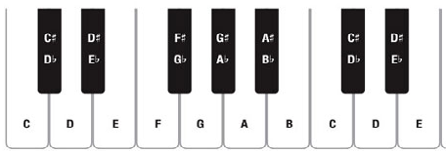
For example:
There is a semitone between C and C#/Db. There is also a semitone between E and F.
There is a whole tone between C and D. There is also a whole tone between E and F#.
Note names:
One note can have multiple names due to the use of accidentals. These are flats, naturals, sharps, and even double sharps and double flats.
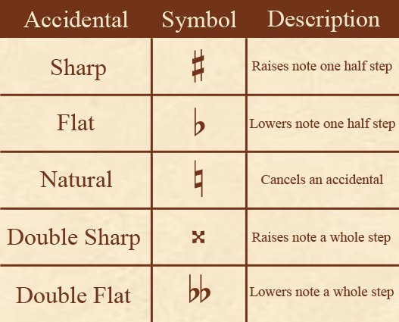
Chromatic and Diatonic semitones:
Chromatic semitones have the same letter name but are a semitone apart like C and C#
Diatonic semitones have different letter names but are a semitone apart like C and Db
Enharmonic notes are notes that are the same but with different letter names like C# and Db

